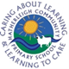 Hatherleigh Community Primary School
Home learning Week beginning 15th June
Year R  Chestnuts | English | Maths | Understanding the world & the wider curriculum
Monday  15th June | Phonics  * https://uk.ixl.com/ela/reception/choose-the-two-words-that-are-the-same  Try and read the words as well.  ** and ***Read through this list of lp words  help, pulp, yelp, gulp, Alps  Write the sentence:  I yelp for help in the Alps.  Writing  This week we are learning about and writing our own water poems.  All: Read ‘splish, splash, splosh’ poem https://www.clpe.org.uk/poetryline/poems/splish-splash-splosh  What do you notice? Do you like it? Talk about how a poem is set out differently to a story. Are any parts of it repeated?  Extension: Look for some other water poems either online or in books at home.  Handwriting:  We are going to continue to learn how to write our letters in cursive formation.  Today our focus is  i and l  Please see in resources an example of how to write these letters. Help your child to practise  either on a whiteboard or on paper.  Extension: Try to write the words ‘ill’ and ‘oil’ joined up. | This week we are focussing on...doubling, halving and sharing.  Doubling:  Watch BBC Bitesize Numberblocks: Double Trouble at https://www.youtube.com/watch?v=Bot83VxMLqM  Remind yourself what doubling is.  * Play ‘Doubles’. Roll 2 dice. If you get a double you get a point. The first person to get 3 points is the winner.  ** Play the game ‘Doubles’ as above but record your addition number sentences e.g. 4+4=8.  *** Make some ladybird/butterfly biscuits and put spots on each side of the wings to show your understanding of doubles. | Understanding the world- Research the water cycle by visiting BBC Bitesize at https://www.bbc.co.uk/bitesize/topics/zkgg87h/articles/z3wpp39  Can you draw and label a picture to show the water cycle?  Physical Development-  Catch up with the latest dance lesson with Miss Squires (details in resources).  or  Try out one of Andy’s Wild Workouts  https://www.bbc.co.uk/programmes/p06tmmvz
Tuesday  16th June | Phonics  All: Read your book or ebook  * https://uk.ixl.com/ela/reception/put-the-sounds-in-order  ** Today we’re looking at the lt consonant blend. Read the story aloud (see resources) -can your child hear the lt words?  *** Ask your child to read the story themselves and find the lt words.  Writing  Listen to the poet performing yesterday’s poem on youtube-discuss the chorus (repeating part).  https://www.youtube.com/watch?v=3k7OQvj8lko  Together, make a list of things that might splash or drip. You might like to think of things you’d find in the kitchen, in a forest, in the snow or in a cave. | Doubling:  Play ‘Hit the Button’ at https://www.topmarks.co.uk/maths-games/hit-the-button  See how quickly you can remember the double facts.  * Complete the ‘Ladybird Doubles to 10’ sheet. Draw on the spots and complete the number sentences below.  ** Complete the ‘Ladybird Doubles to 20’ sheet. Draw on the spots and complete the number sentences below.  *** Complete the ‘Doubling problem solving’ sheet. | Expressive Arts and Design- Claude Monet was a famous artist. You can find out about his life here: https://www.ducksters.com/biography/artists/claude_monet.php  Below are 2 of his paintings that involved water but there are others. Can you have a go at doing your own water picture? You could copy one of Monet’s or do your own. You could use paint, crayons, pencils, pastels or chalk.  Don’t forget to send us a photograph to Class Dojo.  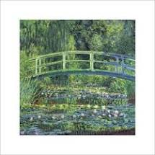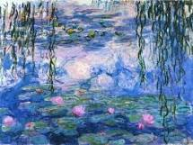  Expressive Arts and Design- If you have musical instruments at home can you make a piece of music that makes you think of water e.g. the rain, a river running or the ocean?
 | English | Maths | Understanding the world & the wider curriculum
Wednesday  17th June | Phonics  All: Read your book or ebook.  * https://uk.ixl.com/ela/reception/identify-the-first-sound-in-a-word  **Read through these words  Half, self, golf, wolf, calf, shelf, elf, myself  ***Read through the words above and use some of them to write a sentence of your own.  Writing  Today we’re going to use yesterday’s ideas to write your poem! Instead of splish splash, splosh! we’re using drip, drop, drip!  Ask your child what things they know that drip and then add ‘do it’ to the end.  For example:  Leaky taps do it  Splashy juice does it  Ice cubes do it  Drip, drop, drip!  *Write down your child’s ideas for them.  **Write one verse of your poem.  ***Try to write more than one verse of your poem. | Halving shapes:  Work through the ‘Halving shapes PowerPoint.’  * Complete the ‘Find a half’ worksheet.  ** Draw around some shapes, cut them out and see if you can fold them in half. Can you find any shapes that you can’t fold in half?  *** Complete ‘Draw the other half’ sheet. | Expressive Arts and Design- Make a Father’s Day card. Remember to hide it away until Sunday. Perhaps you can link your card to our water topic. Below is just an example but remember to send us a photograph of your own creation!  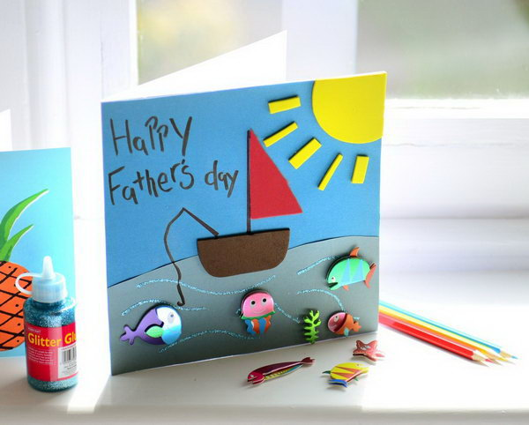  Expressive Arts and Design-Sing the ‘Into the sea song.’ The words are in the resources.
 | English | Maths | Understanding the world & the wider curriculum
Thursday  18th June | Phonics  *https://www.phonicsplay.co.uk/resources/phase/2/pick-a-picture  Play pick a picture game focussing on phase 2  ** and ***Read through these lk words: elk, milk, bulk, silk, yolk, hulk  Complete worksheet where you have to write or stick in the correct ending for the words (lk, lf,lp,lt)  Writing:  In your neatest handwriting write the inside of your Fathers day card.  You can write a simple message or, if you like you could write a DAD acrostic poem. See my example below!  Does fun things with me,  Always kind and happy,  Dad, I love you! | Halving Numbers:  Work through the ‘Halving Numbers’ PowerPoint.  * Have some toys on the floor. Ask your child to count the toys. How many are there? Can you give me half? How do you know we both have half? Repeat with different numbers of toys.  Discuss what happens if you have an odd number of objects.  ** Complete ‘Bees in the garden’.  *** Complete the ‘Halving problem solving’ sheet. | Religious Education- Read in a book or watch the story of Noah’s Ark at https://www.youtube.com/watch?v=QAsfOcGjgoM  Complete the Noah’s Ark puzzle sheet and there’s a colouring sheet too if you like.  Physical Development- Teach your family how to play ‘Fishy Fishy.’  Choose 1 or 2 people to be sharks (depending on how many players you have) and stand at one end. Everyone else is a fish. The fish have to try to get to the other end without being tagged by a shark. If you are tagged you become seaweed and can still tag fish but you can’t move your feet. The game ends when everyone has been turned to seaweed. Remember the words to say at the star of the game:  Sharks- “Fishy fishy come and swim in my sea.”  Fish- “Sharky sharky you can’t catch me!”
Friday  19th June | Phonics  All: Read your book or ebook  */** https://www.phonicsplay.co.uk/ Focus on learning tricky words-phase 2,3 and 4.  ***Reading high frequency words  Or, think of your own games to play to learn to read the tricky words. You could choose 3 words and write them on pieces of paper. Place them around the room. Call out the word and your child has to run to it.  Writing:  Practise reading through your water poem from Wednesday. Can you think of any actions to add to the words?  Perform your poem and ask a grown up to film you. Send your videos into Class Dojo. | Sharing:  Play ‘Fair Shares’ at https://pbskids.org/curiousgeorge/busyday/dogs/  * Have a Teddy Bears picnic. Get some real or pretend food and share it out equally.  ** Complete ‘Sharing at the teddy bears’ picnic’ by drawing the correct number of things onto each plate.  *** Complete the ‘Sharing problem solving’ sheet. | Personal, Social and Emotional Development- Life stages: Who will I be?  Read the book if you have it or watch ‘Once there were Giants’ on Youtube at https://www.youtube.com/watch?v=STwCfjVajys.  Discuss the following:  -What happened to the girl in the story? (She got bigger and grew up)  -Who were the giants in the story? (All the adults – mum, dad, Uncle Tom and her siblings Jill and John).  -Why were they called giants? (They were so much bigger than the baby).  -What sorts of things did the baby do? (Throw porridge/crawl/cry).  -What did she learn to do before she went to school? (Walk and talk, manage her feelings so she didn’t cry when her mum left her at school).  -What happened next? (She got taller than her mum and nearly as tall as her Uncle Tom, her and her brother hit each other. NB: Key point here - explain that when someone grows up with siblings (brothers and sisters) they have to learn to get on and live with each other. This means they learn how to work things out when they are annoyed with each other without hitting each other. Hitting people, even people in your family, is not ok).  -What happened after school? (She got a job, left home, lived on her own for a while, met Don, got married and had a baby).  -Does everyone live their life in that order? What do other people do? (Some people have a baby first then marry. Some people get married but don’t have children. Some people never marry. Some people are unable to work because of an illness or disability).  -Who is a giant at the end of the story? (The woman who has a baby at the end).  -How does she become a giant? (Because she has grown up).  -What has helped her grow up? (Food, sleep, love and care).  Ask the children what they have found out from this story (e.g. that there are different kinds of families and that people make different choices about what to do in their life as they grow older).

