 Hatherleigh Community Primary School
Home learning Week beginning 18th May

Year R  Chestnuts | English | Maths | Understanding the world & the wider curriculum
Monday  18th May | Phonics:  Read your school book or ebook.  https://www.oxfordowl.co.uk/  You’ll need to register but it’s free. You can read books online and search for the correct level for your child by book band.  Continue to practise reading those tricky words.  Go to phonicplay.co.uk  (Username: march20 Password:home)  Play the game Tricky Word Trucks.  or  Play the game below if your child can already read all of the tricky words in their sound book:  https://www.ictgames.com/mobilePage/dinosaurEggsHF/index.html  Writing:  Watch ‘The Very Busy Spider’ on Youtube  https://www.youtube.com/watch?v=TfL0g-XRxnA  Today and tomorrow we are going to be writing our own busy spider story. First, think a little bit about your story.  Where will your spider land (on a farm, in your house, at school, at the park, in space etc)  What other creatures might see your spider and ask him/her questions?  Will your spider catch something in his/her web at the end of the story?  Begin to write your story! Have fun! | This week we are focussing on money.  Re-cap the different coins and make sure you know the value of each one. Remind yourself what ‘value’ means. Can you think of 3 different ways to make 5p? How can you record your work?  * Find all the different ways to make 10p. How many ways did you find?  ** Find all the different ways to make 20p. How many ways did you find?  *** Complete the ** activity THEN complete White Rose maths- The very busy spider- Day 1 at https://whiterosemaths.com/homelearning/early-years/ | This week we are focussing on minibeasts.  Watch ‘The Very Busy Spider’ on Youtube  https://www.youtube.com/watch?v=TfL0g-XRxnA  This is very much linked to the White Rose maths which is the *** activity for maths this week. You might want to take a look if you haven’t already.  Understanding the world- Go on a minibeast hunt. Write a list of all the minibeasts you find or tick them off on the ‘minibeast checklist.’ Think about where you found each bug. What is its habitat? (where does it live?)
Tuesday  19th May | Phonics  Revise the ear sound. Can you think of any ear words? Complete the worksheet. In the top box practise writing ear.  Extension: Use the ear words from the worksheet to write a sentence of your own.  Writing:  Continue to write your own busy spider story. When you finish read it through to check it and then you could draw some pictures to go with it. | Work through the ‘Money Matching power point’.  * Cut out the coins up to 20p and stick on the sheet starting from the lowest value.  ** Cut and stick all the coins in the correct order starting with the lowest value.  *** Complete the ** activity THEN complete White Rose maths- The very busy spider- Day 2 at https://whiterosemaths.com/homelearning/early-years/ | Expressive Arts and Design- Make a model of a minibeast. You could use playdough or clay or you might like to raid the recycling. Remember to send us a picture of your creation!  Physical development- Move like different minibeasts. Flutter like a butterfly, wriggle like a worm, slide like a snail, march like an ant, spin like a spider, scuttle like a beetle and buzz like a bee. Can you think of any others? Choose a minibeast to move like and see if someone can guess which minibeast you are.
 | English | Maths | Understanding the world & the wider curriculum
Wednesday  20th May | Phonics  Revise the air sound. Read the story: Clair at the fair.  *Read story together, focussing on finding those ‘air’ words.  **/***Encourage your child to read the story as independently as they can. Underline or circle all the ‘air’ words.  Writing  Let’s write a factfile for your favourite minibeast! This is today and tomorrow’s work.  - Choose your minibeast.  - Write your minibeast’s name at the top of your page as the heading.  - Draw a picture or print a photograph of your minibeast and stick that under your heading.  - Then, answer the following questions but try to write the answers in full sentences  How many legs does it have?  Does it have wings?  Where would you find me?  You may some more facts that you could write! | Play an online money game at https://www.topmarks.co.uk/money/toy-shop-money  Select mixed coins up to 20p.  * Get a basket of objects (toys or food etc) Label each item a different price up to 20p. You can make your own labels or use the ‘price labels’ document. Play shops with someone. Take it in turns to be the shopper and the shop keeper. Can you give the shop keeper the correct amount of money.  ** Get a basket of objects (toys or food etc) Label each item a different price up to 20p. You can make your own labels or use the ‘price labels’ document. Play shops with someone. Take it in turns to be the shopper and the shop keeper. When you are the shop keeper try to work out how much change you need to give back to the shopper.  *** Complete the ** activity THEN complete White Rose maths- The very busy spider- Day 3 at https://whiterosemaths.com/homelearning/early-years/ | Understanding the world- Make a minibeast hotel. Use your imagination and come up with your own design or take a look at the ‘Make a minibeast hotel’ document. Observe your hotel over time and keep a record of any minibeasts that visit your hotel.  Expressive arts and design- Sing ‘The Ugly Bug Ball’. You can sing along at  https://www.youtube.com/watch?v=utWrIWq2_tk  Take a look at Miss Squire’s latest dance lesson! Details have already been sent out or they can also be found under today’s resources.
 | English | Maths | Understanding the world & the wider curriculum
Thursday  21st May | Phonics  Revise ‘ure’. ‘Ure’ is a funny sound. We teach the children that it can make 2 sounds in words:  - Like in treasure  - Like in manure  Complete the wordsearch which focusses on finding ure words like in ‘manure’.  Extension: Talk about the meaning of the words in the wordsearch-some will be new to your child. You could look the words up in a dictionary.  Superchallenge! Use each ure word in a sentence!  Writing:  Continue with your minibeast factfile (see details above) | Work through ‘how much money is in my piggy bank.’  * Complete pages 1 and 2 of ‘how much money is in my jar’ worksheet.  ** Complete pages 3 and 4 of ‘how much money is in my jar’ worksheet.  *** Complete the ** activity THEN complete White Rose maths- The very busy spider- Day 4 at https://whiterosemaths.com/homelearning/early-years/ | Expressive arts and design- When out walking look out for a stone/ pebble that you could paint to look like a minibeast. Acrylic paints work best as they don’t wash off. You might like to keep your stone or you could hide it around Hatherleigh for your friends to see. Here are a few ideas.  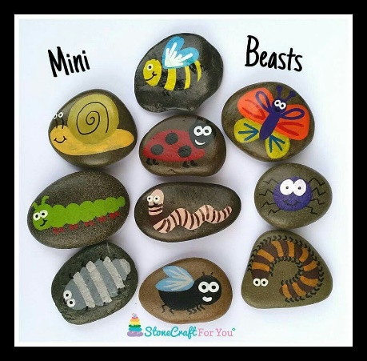  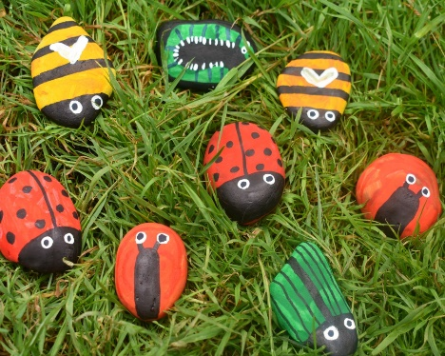
Friday  22nd May | Phonics:  Revise ‘er’. This is the final sound in phase 3! We’ve now gone back over all of them! Wow!  Look at the ‘er’ worksheet.  *Pick out the real ‘er’ words and support your child to read them.  **Read through all of the words. Choose 2 colours and colour all of the real words one colour and the nonsense words the second colour.  *** Same as above but then write a sentence of your own using the some of the real ‘er’ words.  Writing:  You can use today to add more to your minibeast factfile if you like or you could write a card or letter for somebody.  Make a card or write a letter for someone that you haven’t seen recently. You could then post it or pop it through their letterbox if they live close by. Maybe include some nice pictures too? Anything that you think might brighten someone’s day. | Play money game finding change at https://www.topmarks.co.uk/Flash.aspx?f=howmuchleftv2  Select change from 10p to 20p.  * Place a coin under some paper, hold it still and rub over the top with a crayon. Can you do a rubbing of each coin? Can you use the correct colour crayon for each coin? Be careful with the £2 coin as it has 2 colours.  ** Put some coins on the table. Close your eyes and pick up 2 coins. Can you add the coins together? Repeat with different coins.  Play again but this time you and your partner both close your eyes and pick up 2 coins. Who has the biggest value?  *** Complete the ** activity THEN complete White Rose maths- The very busy spider- Day 5 at https://whiterosemaths.com/homelearning/early-years/ | Some of you really enjoyed the 10 minute challenge from Authorfy last week. This week take a look at the video by ‘Swapna Haddow’ at https://authorfy.com/10minutechallenges/  Perhaps you can make up a story about a minibeast? You could write your story, draw it as a comic strip or simple just tell your story. On class Dojo you could upload a video of you telling your story.

