 Hatherleigh Community Primary School
Home learning Week beginning 4th May
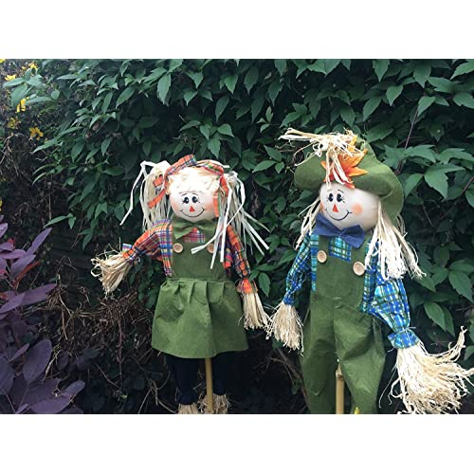
A reminder too that Jess Squires is providing our children with dance lessons on youtube! The dance links have been sent to parents already and look like great fun!
As mentioned in last week’s newsletter, you may also like to make a scarecrow!
With scarecrows being created for the May Day bank holiday being a tradition, we are inviting families to create their own with a theme of 'Best of British.' The scarecrow can be in any form that you would like and either be suitable for outside or just to display inside. They can be 3D or simply pictures.
There are currently 2 scarecrows stood behind the school fence. If you would like your scarecrow to join them they can be brought into the playground next week.
Please send a photograph to pupils@hatherleigh-pri.devon.sch.uk either with or without its creators.

Year R  Chestnuts | English | Maths | Understanding the world & the wider curriculum
Monday  4th May | Phonics  Look at some of the tricky words you have been learning over the past few weeks. Have your adult write the words you’re still practising onto pieces of paper. Put the pieces of paper face down on the table. Set a timer for 1 minute. How many words can you turn over and read in a minute? Or, how many times can you read each word in a minute?  Reading-read a book either from school, home or ebook.  Writing  Check on what is happening with the caterpillars on our class page of the school website. Watch the butterfly life cycle PowerPoint. Order the caterpillar life cycle using the sheet. Can your child explain the different stages of the butterfly life cycle?  Challenge: Write a sentence about each stage. | This week we are focussing on pattern and symmetry.  Work through the ‘pattern power point’ to refresh your mind about patterns. Patterns are all around us.  * Find 3 things in your home that have a pattern on. Make a list of what those things are.  ** Find 5 things in your home that have a pattern on. Make a list of what those things are.  *** Can you think of any animals that have a pattern on? You could look at different animals in books or on the internet. Make a list of the animals you think of. | Butterflies:  Understanding the world- Go into your garden or out on a nature walk and look for different types of butterfly. Use the ‘butterfly checklist’ to help you identify the butterflies you see.  Expressive arts and design- Make a collage of a butterfly. You could draw your own or use the ‘butterfly template’. Stick things on to decorate your butterfly. Think about the different textures you are using. How does it feel? What words can you use to describe the texture?
Tuesday  5th May | Phonics  All: revise ar  Complete ar worksheet.  Extension: Write some sentences using the ar words.  Writing  Write a list of as many other minibeasts as you can think of.  Extension: Go on a minibeast hunt in your garden or on your daily exercise. | Play the Topmarks pattern games at:  http://resources.hwb.wales.gov.uk/VTC/simple_patterns/eng/Introduction/MainSession.htm  * Complete ‘the very hungry caterpillar patterns’ sheet.  ** Draw your own 3 colour repeating patterns.  *** Draw your own 4 colour repeating patterns. | Butterflies:  Expressive arts and design- Choose one of the ‘butterfly shape cut outs’ to colour and cut out. Attach it to a lollipop stick or a straw. Roll the wings into the centre and slide it into a toilet roll tube. Gently push the butterfly out to look like it is emerging from its cocoon.  You can also use toilet roll tubes to make your own butterfly.  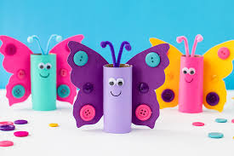
 | English | Maths | Understanding the world & the wider curriculum
Wednesday  6th May | Phonics  Revise oo. We have learnt about how oo can make a long oo sound (like moon) and a short oo sound (like book).  Complete the worksheet. Afterwards read through all of the words. Can you underline the words with a long oo sound?  Extension: Complete the oo wordsearch.  Writing:  All: Start a rainbow diary-see school letter explaining it. Please note though that we don’t expect Chestnut children to write 500 words! Please adapt the task as you feel appropriate. Tomorrow’s writing task will be to continue with your rainbow diary. | Numbers can be in patterns too. Can you count in 2s to 20? Remember you miss a number out each time or say it quietly to yourself but say the multiples of 2 out loud.  Play a game at:  https://www.topmarks.co.uk/ordering-and-sequencing/chinese-dragon-ordering  Select ‘sequencing’ then ‘counting in 2s 0-20.’  * Complete the ‘counting in 2s sheet’. Write in the missing numbers. You only need to choose one season to complete.  ** Complete the ‘counting in 10s sheet’. Write in the missing numbers. You only need to choose one season to complete.  *** Complete the ‘counting in 5s sheet’. Write in the missing numbers. You only need to choose one season to complete.  Challenge!  Complete all the seasons when counting in 2s, 5s and 10s. | Butterfly Dance:  Physical Development- Think about the stages of the life cycle of a butterfly. Put together a dance sequence to show the different stages. Think about what shape you could hold to be the egg (tuck), slowly hatch into a caterpillar and show how they move and eat. Gradually curl up into a cocoon/chrysalis, start to wobble and shake a little before hatching into a butterfly. Remember to stretch your wings and let them dry before flying around. Don’t forget to lay more eggs so the life cycle can continue. You could ask someone to record your dance and post it on class Dojo.
 | English | Maths | Understanding the world & the wider curriculum
Thursday  7th May | Phonics-Our focus today is on fine motor and pencil skills. Complete the rainbow tracing sheet as carefully as you can. Make sure that you are sitting up at a desk or table, holding your pencil or pen properly and really looking at the lines you need to follow.  Reading-read a book either from school, home or ebook.  Writing: Continue writing Rainbow diaries. | Symmetry:  Watch the BBC Bitesize clip about symmetry at:  https://www.bbc.co.uk/bitesize/clips/ztpyr82  Play the matching game at:  https://www.topmarks.co.uk/symmetry/symmetry-matching  * Complete one of the butterflies on the ‘butterfly symmetry worksheet’ by drawing the spots onto the other side and colouring so the butterfly is the same both sides.  **Complete page 1 of the ‘draw the other half’ activity. If you find it tricky you could use a mirror to help you.  *** Complete both pages of the ‘draw the other half’ activity. If you find it tricky you could use a mirror to help you.  Challenge!  Use the ‘butterfly template’ to paint a pattern on one side of the butterfly. Fold carefully down the centre and press to make a symmetrical butterfly. | VE Day:  Understanding the world- Ask your parents to tell you what they know about VE day. Read the ‘VE Day power point presentation’ to find out more.  Colour in the ‘VE Day colouring page.’  Challenge! Look at the ‘wartime recipe booklet’ and choose one to make. Don’t forget to send us a picture and let us know how it tastes.
Friday  8th May | BANK HOLIDAY!

