Chestnuts Art Thursday 28th January 2021
This week you have the choice of 2 activities. Please choose one to complete.
- Arcimboldo was a famous artist who would often use fruit and vegetables to make pictures. Look at the image below:

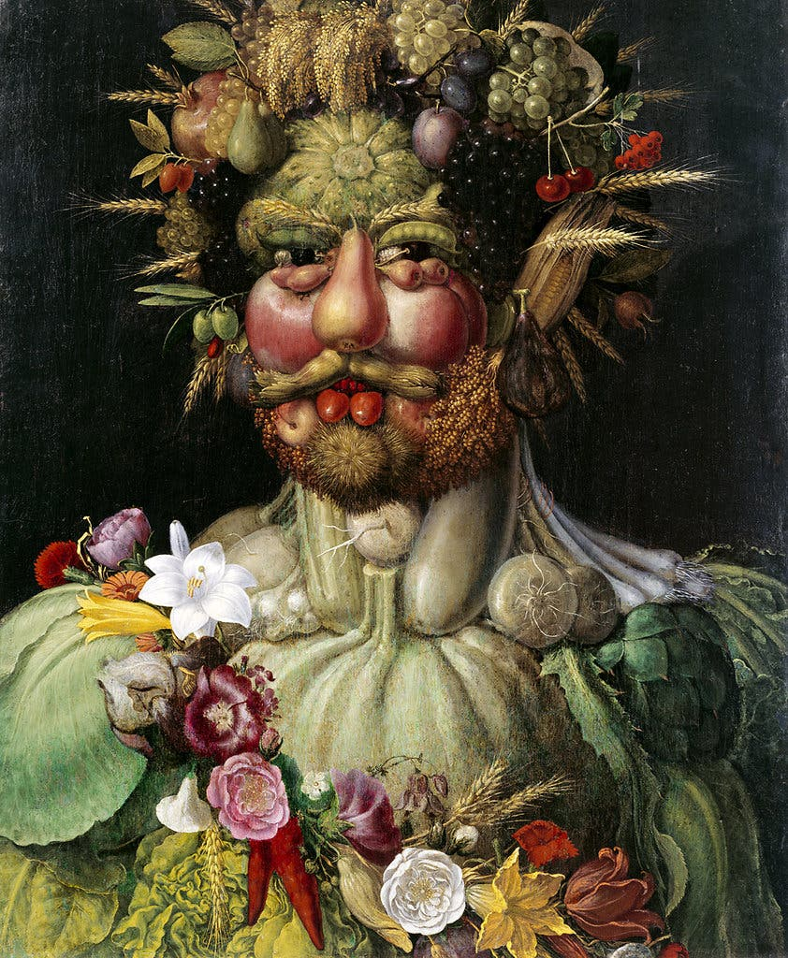

What fruit and vegetables can you see?
Using food you have at home, can you make a simple picture of your own? It could be a face or anything else you like. I’ve popped an example below.
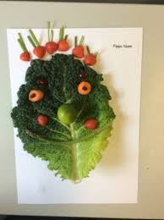
- Our second idea for an Art activity is potato printing. Make sure an adult does the actual cutting of your potato. Below are some ideas you might like to try.

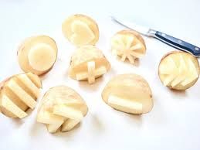 | 

