Task 1:
Re-read The Highwayman Poem https://www.poetryfoundation.org/poems/43187/the-highwayman

Task 2:
Describe these characters using as many adjectives as you can. Use a thesaurus to help you to find synonyms and write the vocabulary underneath the pictures.

The Highwayman
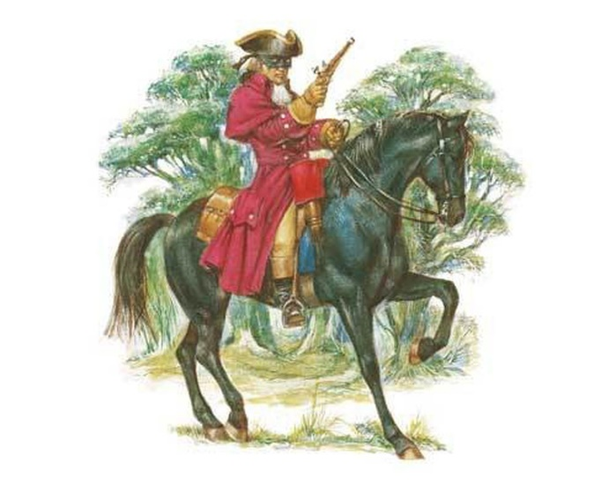

Brave
Selfish
Arrogant

Bess



Task 3:
Using the adjectives that you have collected, write a riddle for one of the characters in The Highwayman. This could be for The Highwayman or Bess. Here is an example of a riddle written by a Year 5 student:


