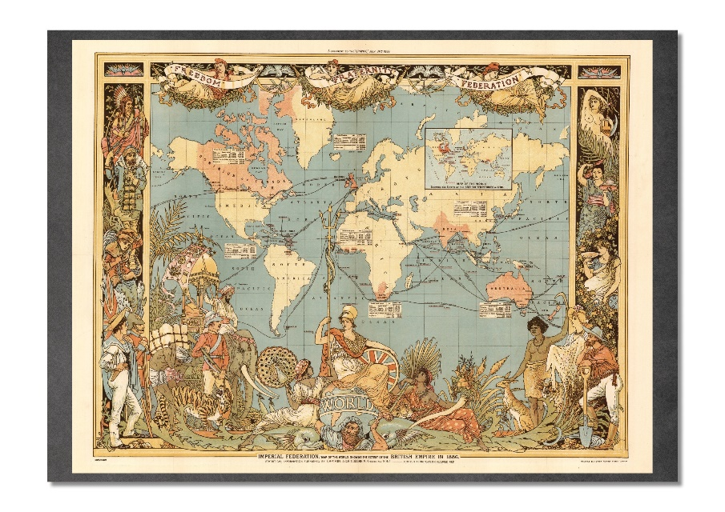

How long do you think it took to sail from England to America? What might the journey have been like?
__________________________________________________________________________________________________________________________________________________________________
What do you think they ate and drank?
__________________________________________________________________________________________________________________________________________________________________
What sort of jobs do you think sailors did on the ships?
__________________________________________________________________________________________________________________________________________________________________
What sort of jobs do you think sailors did on the ships?
__________________________________________________________________________________________________________________________________________________________________
What punishments were there if you did something wrong?
__________________________________________________________________________________________________________________________________________
Extension: In the role of a sailor, write a letter home from one of the trade ships to your family.

