Orange
What is 3²?
What is 2²?
What is 4²?
What is 6²?
What is 7²?
What is 8²?
What is 2³?
What is 3³?
What is 4³?

Red
What is 4²?
What is 6²?
What is 8²?
What is 11²?
What is 9²?
What is 16²?
What is 18²?
What is 4³?
What is 5³?
What is 6³?

Blue
What is 6²?
What is 9²?
What is 8²?
What is 7²?
What is 19²?
What is 14²?
What is 5³?
What is 7³?

Challenge
2² + 3³ =
5³ - 2² =
9³ - 7² =

Yellow
What is 10²?
What is 13²?
What is 14²?
What is 5³?
What is 6³?
What is 7³?

Challenge
3² + 4³ =
2³ + 3³ =
7³ - 3² =
9³ - 7² =

RedBlue Table

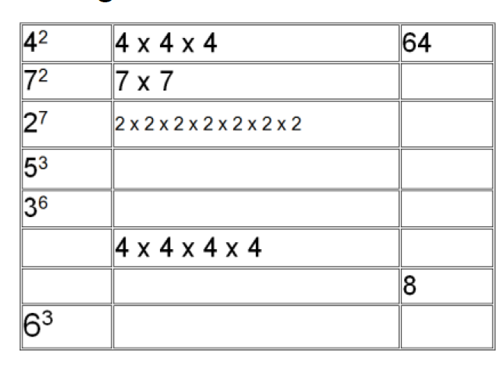

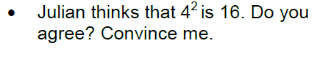

Yellow Table

Jack thinks 15² is 300 . Is he correct? Explain your answer. _____________________________________________
____________________________________________________________________________________________________________________________________________________________________________________

Billy says that 10³ is 1000. Is she correct? Convince me!____________________________________________________________________________________________________________________________________________________________________________________________________________________________________________________________________________

Always, Sometimes, Never.
Square and Cubed numbers are always positive? Explain your answer. _____________________________________________
____________________________________________________________________________________________________________________________________________________________________________________

