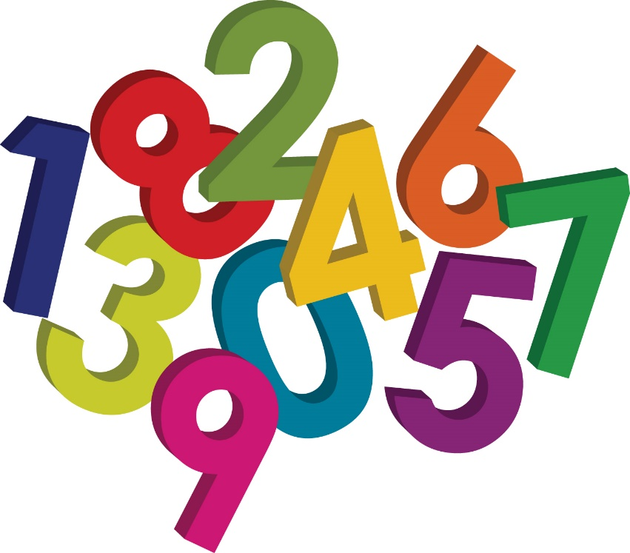

Maths Booklet

Division

Beeches

The aim of this booklet is to outline what is expected by the end of the year. We have included some of the strategies that will be used in class so that support is given in the same way.

Division Expected targets.
- Divide numbers mentally drawing upon known facts
- Divide numbers up to 4 digits by a one-digit number using the formal written method of short division and interpret remainders appropriately for the context
- Divide whole numbers and those involving decimals by 10, 100 and 1000

Children in year 5 need to appreciate the difference between grouping and sharing when dividing.
E.g. 21 sweets shared between 3 people means that each person gets 7 sweets.
However
Putting 21 sweets into groups of 3 means that there will be 7 groups.
Both these different problems are solved by doing the below calculation.
21÷3=7
In Year 5 children need to use more formal written methods to solve more tricky calculations but need to use their understanding of the link between division and multiplication to choose the most suitable method.

Short division HTU ÷ U
196 ÷ 6
6 x 30
6 x 2

0 180 192 196
Remainder 4

Answer : 32 remainder 4 or 32 r 4
Any remainders should be shown as integers, i.e. 32 remainder 4 or 32r4.
A vertical number line can be used in the same way to add on multiples of the divisor until the target number is reached.

‘How many 5s are there in 72?’

72

Remainder 2
70

+ 20 (5 x 4)
50

72 ÷ 5 = 14 r 2

+ 50 (5 x 10)

0

This then feeds into short division through subtracting multiples of 5.
72 ÷ 5

5 ) 72
- 50 5x10
22
- 20 5x4
2

Answer : 14 r 2

Leading to subtraction of other multiples.
96 ÷ 6

1 6
6 ) 96
- 60 6x10
36
- 36 6x6
0

Answer : 16

Long division HTU ÷ TU
972 ÷ 36
27
36 ) 972
- 360 36x10 (10 lots of 36)
612
- 360 36x10 (10 lots of 36)
252
- 252 36x7 (7 lots of 36)
0

Answer : 27 (lots of 36)

The following websites are all good:
http://www.mad4maths.com/multiplication_table_math_games/ http://www.interactivestuff.org/match/maker.phtml?id=5 https://www.cgpbooks.co.uk/interactive_ks2_maths_sevenTimesTable http://www.arcademics.com/games/meteor/meteor.html http://www.resourceroom.net/math/eightetal.htm http://www.ictgames.com/spitfireufo.html http://www.ictgames.com/multiBounce/ http://www.learnyourtables.co.uk/en/index2.htm
For a small charge, the squeebles app can be purchased for iPad or android tablets. This has been shown in school to be highly effective for learning tables.

