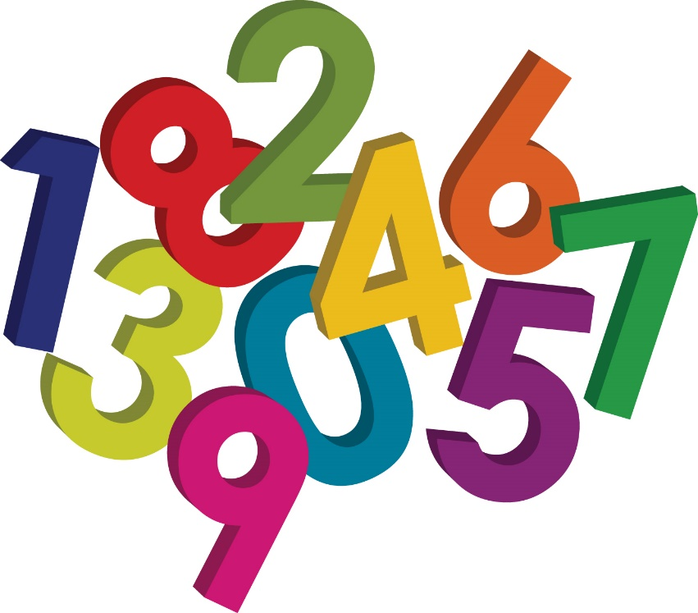

Maths Booklet

Subtraction

Beeches

The aim of this booklet is to outline what is expected by the end of the year. We have included some of the strategies that will be used in class so that support is given in the same way.
We have included some games and activities that can be done at home to help them develop fluency and understanding.

Subtraction Expected targets.
- Subtract whole numbers with more than 4 digits, including using formal written methods (columnar subtraction)
- Subtract numbers mentally with increasingly large numbers
- Use rounding to check answers to calculations and determine, in the context of a problem, levels of accuracy
- Solve subtraction multi-step problems in contexts, deciding which operations and methods to use and why.

Children in Upper KS2 need to make decisions about which is the most efficient and appropriate method for each problem they face. Some may need problems need a formal column method while others can be done mentally. A secure understanding of numbers and how they relate together is really important.

Vertical Subtraction/Decomposition

754-86=

₆₁₄ ₁
//
754
- 86
668

Children should:
- be able to subtract numbers with different numbers of digits;
- using this method, children should also begin to find the difference between two three-digit
- amounts of money, with or without ‘adjustment’ from the pence to the pounds;
- know that decimal points should line up under each other.

For example:

£8.95 = 8 + 0.9 + 0.05
-£4.38 - 4 + 0.3 + 0.08

leading to
₁
/
= 8 + 0.8 + 0.15 (adjust from T to U) 8.85
- 4 + 0.3 + 0.08 - 4.38
4 + 0.5 + 0.07 4.57

= £4.57

Alternatively, children can set the amounts to whole numbers, i.e. 895 – 438 and convert to pounds after the calculation.

This method can then be used for calculations with more digits.

6894-3286= or 64.67-26.84

₅ ₁₃ ₁
64.67
- 26.84
37.83
₅ ₁₇ ₁₈ ₁
/ /
/
//

6894
- 3286
468

However where the numbers are involved in the calculation are close together or near to multiples of 10, 100 etc counting on using a number line should be used.

511 – 197 = 314
+300

+11
+3

0 197 200 500 511

or

2001-1998 = 3

+1
+2

0 1998 2000 2001

Similarly

3002 – 1997 = 1005
+1000

+2
+3

0 1997 2000 3000 3002

Most importantly children must look at the numbers involved in the calculation and make a decision based on the numbers in the problem. Some will be best solved mentally using known number fact
Eg 1000-750=250 or 1-0.75=0.25

Others will require a formal vertical method simply because there are too many numbers to try to remember and too many numbers to carry over.
Eg 24106.75-987.87

Some calculations look complicated but can be solved simply by subtracting each column in turn as there is no need to carry over.
Eg 789.67-345.2

Children need to be very familiar and comfortable with what subtracting is and all the different ways .it can be presented to us in the real world.

Practising mental subtraction at home could be:

Calculating the how much change you get when in a shop.
Seeing how many pages are left in a book you might be reading.
Calculating how much heavier different items are.
Comparing how much taller someone is than someone else.

