Sorry to hear you are unwell.
If you are feeling well enough to work while you are isolating here are some of the activities that we will be covering in class. We would like to see any work that you do, even if it isn’t what we have sent, when you return to school. ANy problems contact us through the Year4@ email and we will get back to you as soon as we can.
Best wishes
Year 4 team

Maths this week we are continuing with multiplication and division.
Remember you have access to TTRS and can practise your tables any other ways too
The PowerPoint slides might be useful for some instructions (we don’t use the workbook so ignore those slides) and if you have someone you talk the ideas through with that would be great. Just do your best.

English.
We can’t send you the text that we will be reading in class but will include the tasks and the answers. Again, if you can chat with someone about it that’s better. When comparing Lucy and Joe’s world have a think first what the differences might be. Remember he has travelled back in time to Rome. Use what you know about ancient times to have a think how different that is to now.
We are continuing to work on adverbs. The examples of adverbs of time and adverbs of manner are included, if you don’t feel up to writing you can practise using them in sentences during the week while you are talking, that will be just as useful.
With the letter writing on Friday, we have included an example. Remember you are Joe and writing home to Mum. You can include what has happened up to where you have heard, how would he feel. Write it in an informal style, keep it chatty.
You have your own spelling list (year 2/3/4) to practise but we will also look at the following.
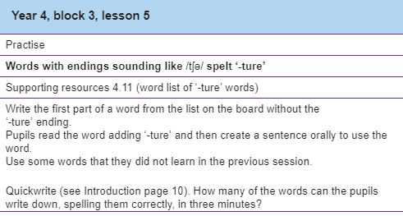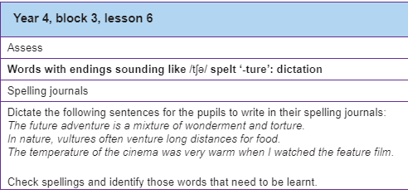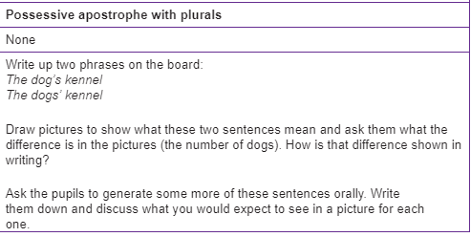EgThe cow’s field. The cows’ field.
The teacher’s book. The teachers’ book. The boy’s football. The boys’ football.
The girl’s dresses were white. 1 girl with lots of dresses.
The girls’ dresses los of girls with white dresses on
The boy’s oranges tasted delicious (1 boy with a pile of oranges )
The boys’ oranges tasted delicious ( several boys all with an orange)
At the museum the guard’s clothes were smart. (one guard)
At the museum the guards’ clothes were smart (several guards)

You have your own reading you can do but we have also included the comprehension. Choose the level that sits you and don’t look at the answers until you have finished.

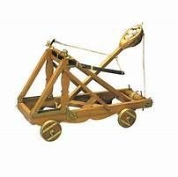
For topic this week we are looking at and will make a Roman shield. Use books or the internet to see what designs and shape the Romans used. We are also looking at a Roman Onager , a catapult. Would you be able to use anything at home to make one? There’s a challenge.

Find time for some exercise if you feel well enough too.
While you are at home it might help to keep in a routine, maybe work in the morning and then have a break. If Mum, Dad or whoever is looking after you are having to work as well see what you can do to help them. This might the week to tidy your bedroom 😉 , help with the cooking and practise your hoovering skills.
Hope you are feeling better soon
Best wishes
Year 4 team.

