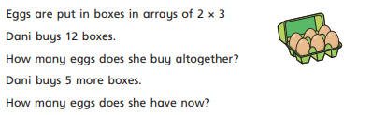  A.  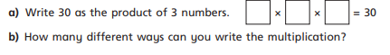 | B.  Write 30 as the product of 3 numbers.    How many different ways can you write the multiplication?
A. | B.  Write 30 as the product of 3 numbers.  How many different ways can you write the multiplication?
A. | B.  Write 30 as the product of 3 numbers.  How many different ways can you write the multiplication?

